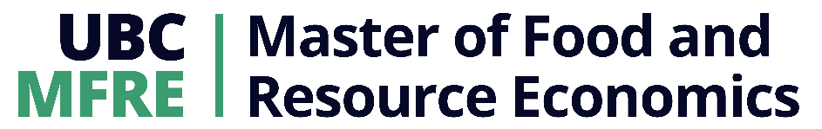

2023 MFRE SUMMER PROGRAM
Python Workshop 1: Data Types, Lists, and Programming Basics

CASE
We’re exploring a dataset on the carbon emissions of Canadian provinces. Before we get off to the races with visualization, modelling, and the real fun stuff, we need a solid grasp of the fundamentals. We’ll put our carbon data into Python lists, and learn the basic techniques for working with iterable objects in Python. In our next workshop, we’ll expand these fundamental techniques to work with the much more complicated DataFrame objects.

- Data types and structures
  - Simple data types:
    - Strings
    - Floats
    - Integers
    - Booleans
  - Lists
    - `if` statements
    - Loops
    - Functions
- Python List Deep Dive
  - Sorting lists
  - Indexing lists
  - Appending to lists
  - Removing from list
  - Mapping functions to list
  - Filtering a list
  - Iterating through multiple lists
  - Capstone: totaling 2005, 2021 emissions

Sample Exercises

- Sort a list from greatest to lowest.
- Access specific values in a list.
- Appending multiple values to a list.
- Removal of specified nonsense values from a list.
- Write a function that multiplies values by one million, and map it to a list.
- Iterating through a list and applying a user-defined function to each element.
- Filtering to the emissions values above 50 but below 200.
- Identifying provinces with lower carbon emissions in 2021 than 2005.
- Totaling emissions in 2005 and 2021, then plotting to compare them.

